**Unit Testing:**

Create a Unit Test:

dataService.spec.ts test file

Jasmine is the testing framework:

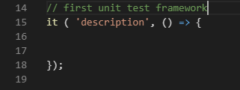

Does the addBook method increase the number of books?

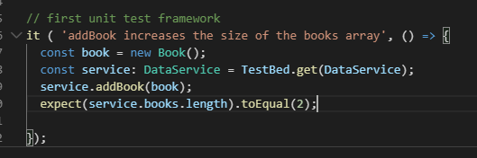

**To run a test:**

Stop the terminal and type ng test

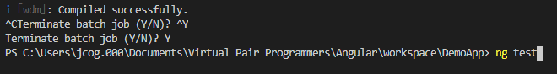

Add an f to what you want to run it to fit

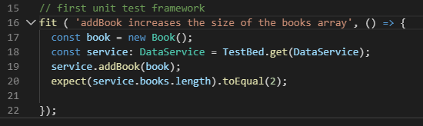

Press Enter

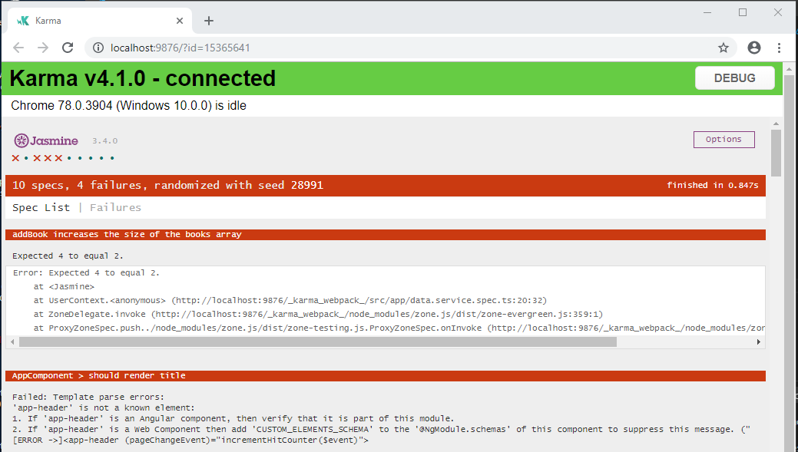

Fix the failing test

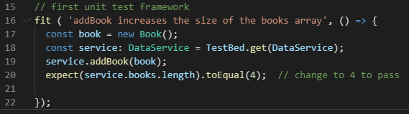

Test passed

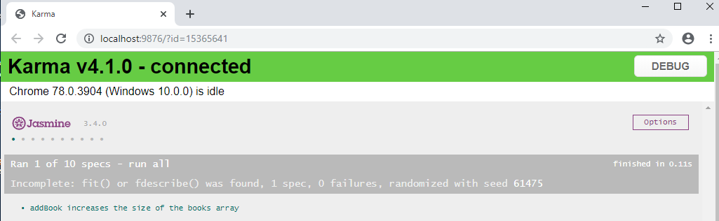

There is a fail() method

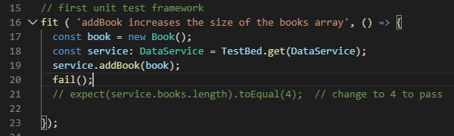

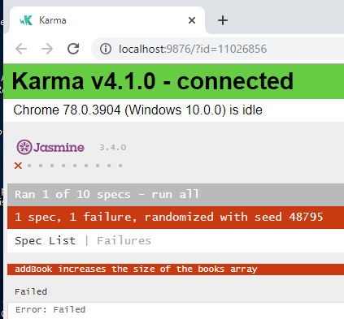

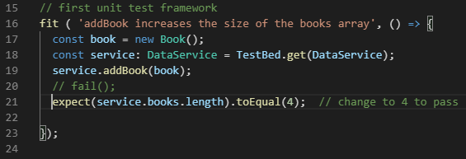

**Test Evaluation Methods:**

ToBe is about Object Equality

Falsy If you can cast to Boolean it will be false

Truthy if you can cast to Boolean it will be true

**Use toEqual to check Boolean values!!!!**

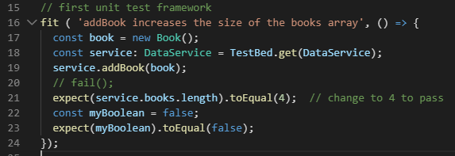

**To run all tests remove the f and execute > ng test**

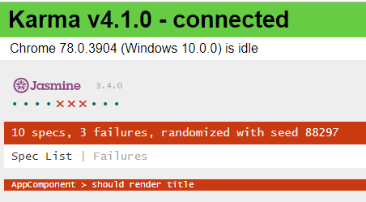

**Let us fix the failing tests**

**App.component.spec.ts does not know about the additional declarations and elements**

**Added to the application**

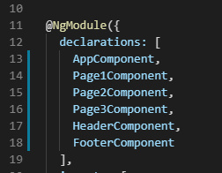

**In the app.component.spec.ts file declaration these only AppComponent exists**

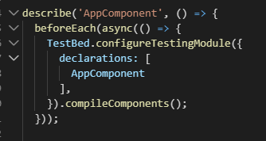

**So, lets add the other missing parts**

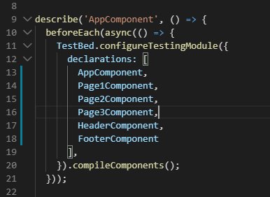

**Rerun tests**

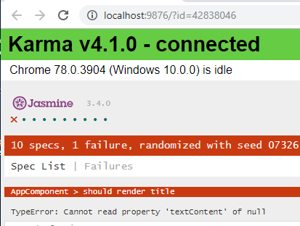

**In page1.html**



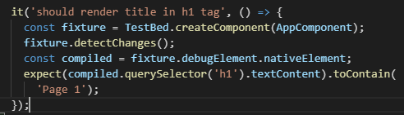

**Rerun tests**

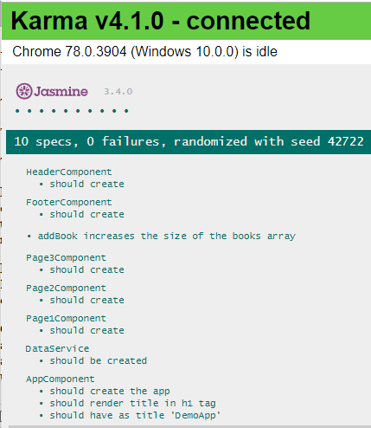

**All tests now pass!!**

**Testing Behavior:**

**When we addBook is the emitter triggered?**

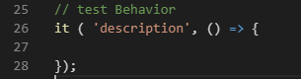

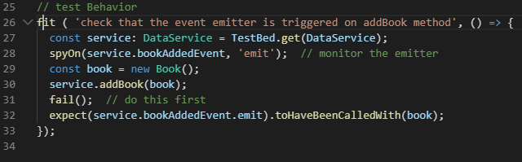**Test failure**

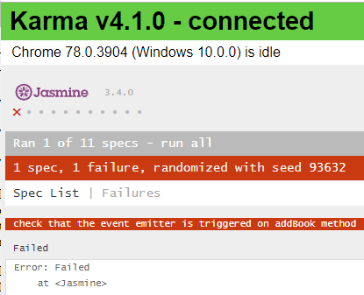

**Remove the fail() and test**

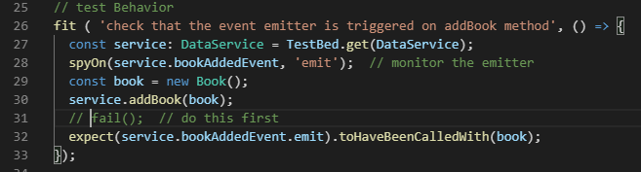

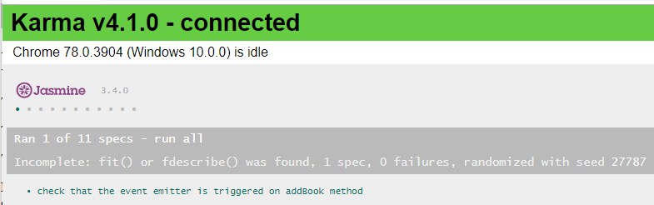

**Checking Dependencies:**

**In the page1.spec.ts file**

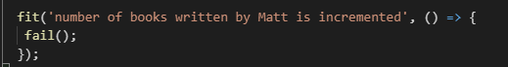

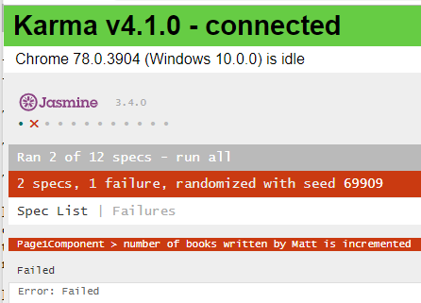

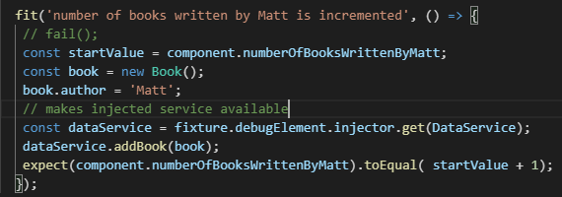

**Test**

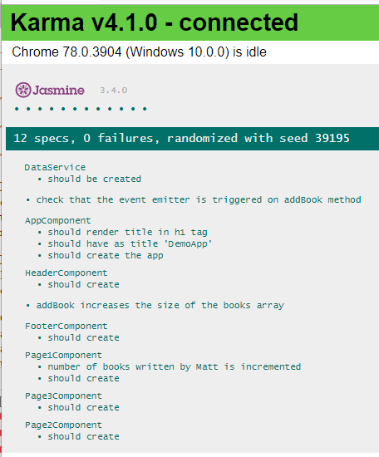

**Another way of testing**

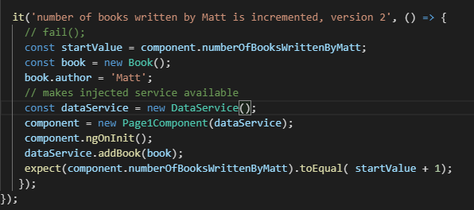

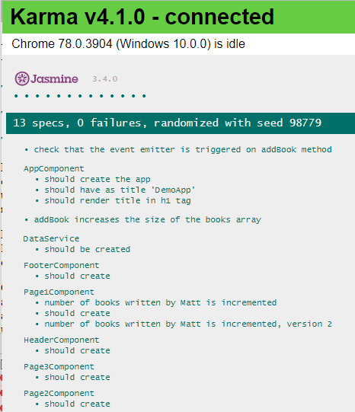

**Mocking Services:**

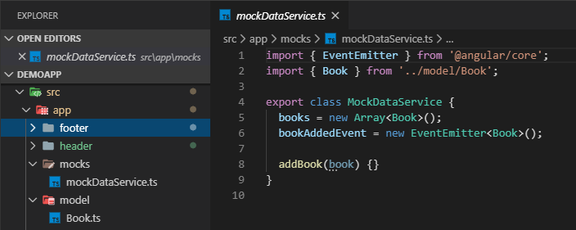

**Now the version 2 injection test can use the MockDataService**

**Add an interface to the dataService.ts file**

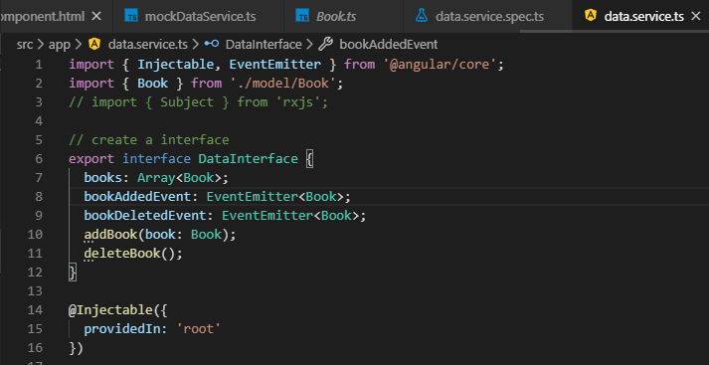

**Add the implementation**

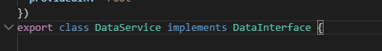

**Update the MockDataService**

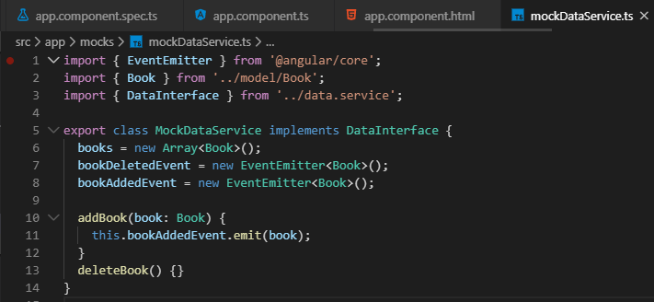

**Change all the constructor params to DataInterface**



**In the app.module.ts add the following to providers (This is repeated later to show what the error is )**



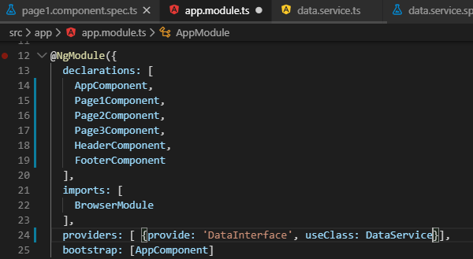

**Add the @Inject() label to all the constructors: page1.component.ts and page3.component.ts**



**Copy and paste the provider into the test class page1.component.spec.ts and page3.component.spec.ts files**

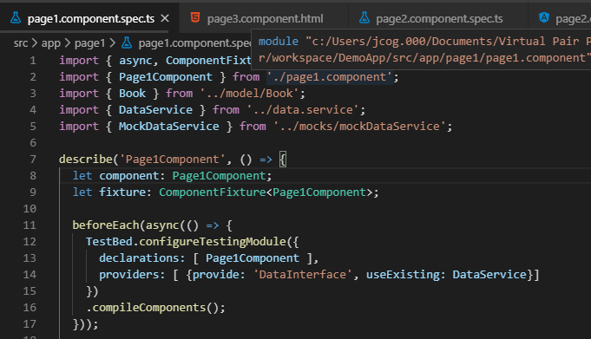

**Update position for startValue to after ngOnInit() in page1.component.spec.ts**

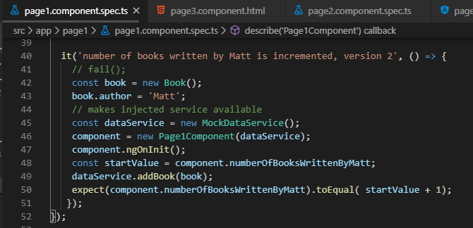

**Modify the app.module.ts file to have the provider:**

**Fixes this error:**

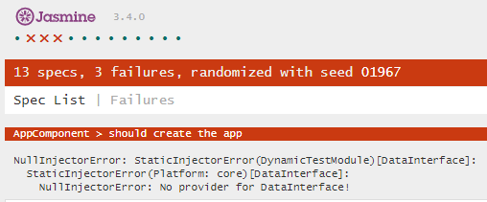

**Adding the providers: [{provide: ‘DataInterface’, useClass: DataService}] fixes this**



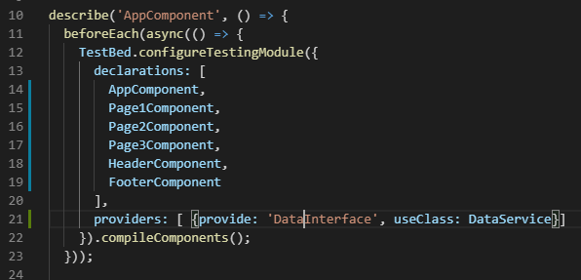

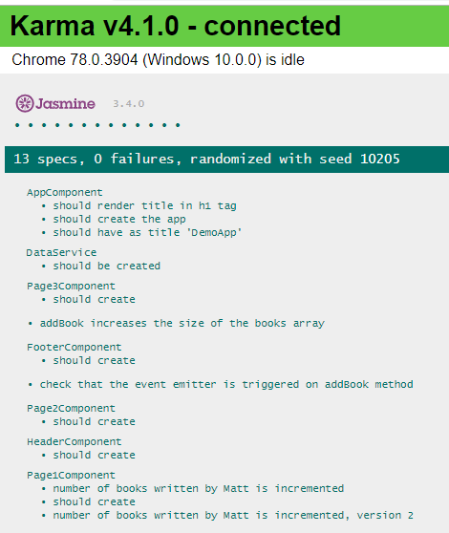

**Fix footer.component.ts refactor:**

**Add the @Inject()**

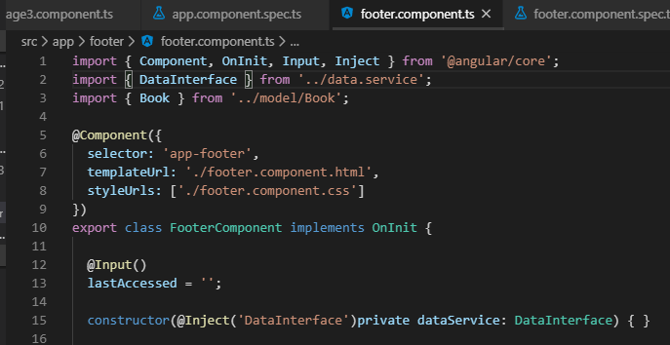

**Fix footer.component.spec.ts refactor:**

**Add the provider**

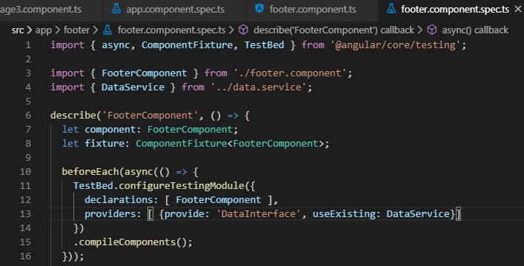

**Now the Delete works with Add Books**